## Common Style Errors

**Code formatting**

Please format your code correctly! For Processing, use Control-T on Windows or Apple-T on Mac.

Here is an example of unformatted code from an anonymous source:

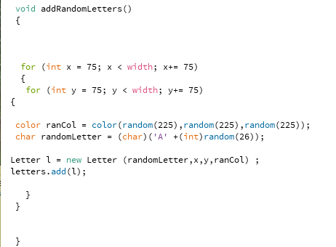

Can use easily understand the code? Could you easily spot an error?

Here is the same example with correct formatting:

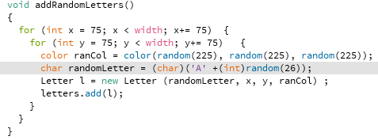

**Naming of variables**

Remember to use proper naming.

If a method is simple, for example with a single for loop, then using a generic name such as “index” is fine, e.g.

for (int index=0; index<letters.size(); index++) {

// do stuff

}

However using generic names becomes confusing if your method starts to get more complicated:

for (int index=0; index<grid.size(); index++)

for (int i=0; i<grid.size(); i++) {

// do stuff

}

As a reader I am confused about the difference between “index” and “i”.

A much better solution:

for (int columnIndex=0; columnIndex<grid.size(); columnIndex++)

for (int rowIndex=0; rowIndex<grid.size(); rowIndex++) {

// do stuff

}

It’s a little more typing, but it makes the program much more understandable!

**Naming of Methods**

Remember to use lowerCamelCase to name methods. UpperCamelCase is C# convention.

For example:

public void DrawLetter() {..} // C#

public void drawLetter() {..} // Processing